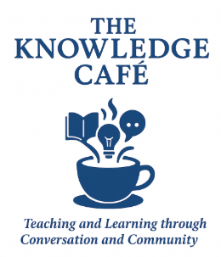
National Louis University’s Ed Prep Program welcomes you to The Knowledge Cafe - a year-long professional development series where teaching and learning happens through conversation and community!

This SY 2025-26 theme is Field Experience Success
and is dedicated to supporting students as they make the exciting transition from theory to practice with their field experience. Whether you are in courses with field hours or methods hours requirements, are in Practicum or Student Teaching, or simply want to learn more and start preparing for the classroom, transitioning from one classroom to another is easier said than done.

This Field Experience Success series will help you prepare for the various roles, responsibilities, and expectations of being a teacher. At National Louis University, we believe being a teacher is so much more than just a job. It is a career, it is a calling. So take a look at the schedule to find out more about our engaging monthly session topics and registration details here:




THE KNOWLEDGE CAFE - FIELD EXPERIENCE SUCCESS SERIES SCHEDULE

Echoes of the Past: How Historical Views of Disability Resurface in Modern Systems
-- Presented by Connor See,
Chair of Special Education

Tuesday, April 21, 2026
6:00 – 7:00 PM

Zoom Link: https://nl.zoom.us/s/3122613752
Presented by the Educator Prep Department, in collaboration with the Office of Field Experiences
What You’ll Learn In this session, participants will examine how historical beliefs about disability continue to influence modern educational systems, policies, and classroom practices. You will explore how deficit thinking, segregation, and gatekeeping have evolved over time and how these echoes still shape expectations, access, and opportunity for students today. Together, we will unpack how educators can recognize these patterns and intentionally shift toward inclusive, strengths-based approaches that center equity, dignity, and belonging.

Why This Matters: Understanding the historical context of disability is essential to disrupting the barriers that persist in today’s schools. Many practices that seem neutral or routine are rooted in past systems that limited autonomy and access for individuals with disabilities. By recognizing these connections, educators can make more intentional decisions that challenge outdated assumptions and create learning environments where all students are valued, included, and empowered to succeed.
have the opportunity to improve and succeed.
Register here: https://cglink.me/22Q/r376154

Connor See,
Chair & Assistant Professor of Special Education
